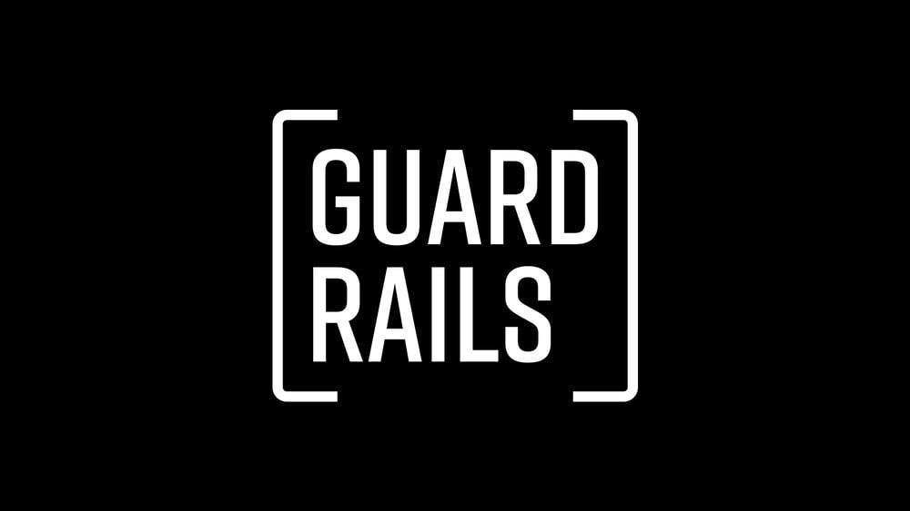
Introduction
Have you ever met someone that you later wish you hadn’t? Is there a person that you wish your husband, wife, son, or daughter had never met? Sometimes people are our greatest regrets because they influence us to ignore our guardrails and step into the danger zone.
Discussion Questions
- Who is someone in your life that has stood by you in good times and bad?

- Talk about a time when you saw someone suffer because of his or her relationships. What happened?

- Read Proverbs 13:20. Who is a person in your life whose wisdom you rely on? In what ways hae you seen his or her wisdom rub off on you over time?

- During the message, it was said that there is a difference between being judgmental and using good judgment. What is the difference? To what extent has not wanting to be judgmental drawn you into unhealthy relationships in the past? How can understanding the difference between judgmental and good judgment help moving forward?

- How can friendships influence the direction and quality of your life? What makes a friendship powerful? Can what makes a relationship powerful also be dangerous?

- What is the hardest part about putting up guardrails in regards to friendships? What is the danger in not putting up a guardrail?

- How can we put up guardrails in regards to relationships and still be faithful to our mission of extending hope to people who are not headed in the same direction?

- Is there a relationship in your life that could benefit from some guardrails? What can you do to begin that process?

Shaping Your Mind – “ Walk with the wise and become wise, for a companion of fools suffers harm. Proverbs 13:20
Moving Forward –. Friends influence the direction and quality of your life. Is your core group moving in a direction consistent with where you want to go? Do you feel pressure to compromise? If so-it’s time to establish some relational guardrails.

