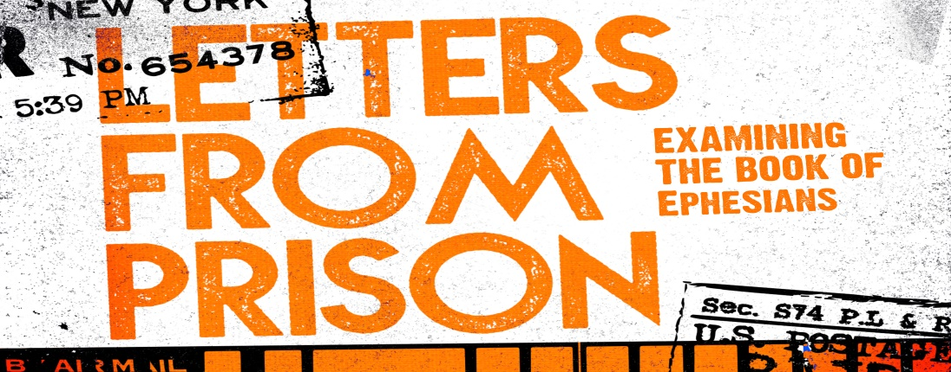
Introduction
As Paul wraps up his letter to Ephesians he says that we are in a battle, but not with flesh and blood. To stand our ground against the evil forces that we are battling we need to put on the whole armor of God.
Discussion Questions
- Have you ever participated in an activity that required protective gear without the protective gear or done something that should have required protective gear?

- Read Ephesians 6:10-13 What does it look like to be strong in the Lord? Why does Paul say we are in a struggle but not against flesh and blood? 2 Common errors when it comes to thinking about evil forces are to dismiss them or be too interested in them. What are the dangers of those approaches?

- What are the devils schemes? How does he most commonly attack? Are there any schemes that you might be more vulnerable to?

- Read Ephesians 6:14-20 How do these pieces of the armor work together? How do we get this armor?

- Talk about each piece of the Armor of God – Belt of Truth, Breastplate of Righteousness, Shoes (Gospel of Peace) Shield of Faith, Helmet of Salvation, Sword of the Spirit. Are there any pieces that surprise you? Any pieces that you feel like you forget to put on sometimes?

- What does it mean that all but one of the things Paul mentions are defensive weapons? Is it significant that there is nothing to guard the back?

- Paul says to pray with all kinds of prayers on all kinds of occasions. What does that say about what God wants from us in prayer? What can we pray together about?

Shaping Your Mind - Therefore put on the full armor of God, so that when the day of evil comes, you may be able to stand your ground, and after you have done everything, to stand. Eph. 6:13

