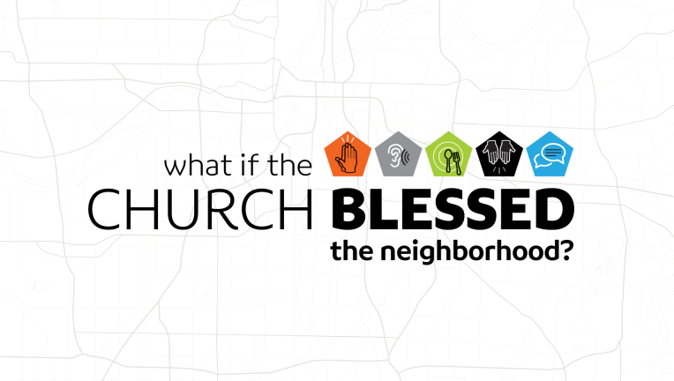
Introduction
“What if” is a powerful thought? Most great ideas (and some bad ones) begin with that thought. What if we began to see the church in Kansas City as more than just the place where we meet on a given week? What if we each practiced being the church where we live work and play?
Discussion Questions
- What is something that is common place today that you used to think would never happen (or didn’t think of because you didn’t think it could happen)?
- Do you view your home as a refuge or a missionary field office? Which one seems stranger to you?

- When we talk about over 40 churches doing this series together, across denominational lines, what kinds of thoughts or emotions does that prompt in you?

- Read Genesis 12:1-3 Abraham was told he was going to be blessed and in turn he would be a blessing. Why do you think God would use this idea –to bless someone in order to bless others? When we talk about our blessings, do we act like those are just for us or for others as well?

- Read Isaiah 6:8 and Isaiah 61:1-3 – In the sermon, Jeremy talked about the missionary nature of God. He calls and he sends. How does or should that nature be reflected in the church?

- The Incarnation, means that God put on flesh and moved into the neighborhood. If the Holy Spirit lives in us-how should that shape how we look at our interactions in the places where we live, work, and play?

- BLESS – Stands for Begin in Prayer, Listen and Engage, Eat, Serve, and Story. When you look around your neighborhood-we want you to ask the prayer, “Lord where are you at work, and how can I join you?” and listen for the answer. How can/will that flavor how you view your neighbors?

Shaping Your Mind – “…I will bless you…and all peoples of the world will be blessed through you…” Gen. 12:2
Moving Forward – Go to Blesseveryhome.com and sign up to be a light-using Northside…and begin to pray for your neighbors by name!

