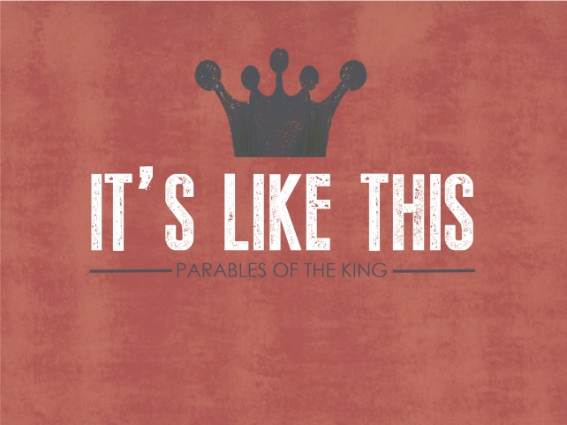
Introduction
While the kingdom is open to everyone, the kingdom way of life must be accepted to be a part of it. Our response to the invitation is to both accept the offer and change our way of doing life. This has to do with God loving you the way you are, and too much to have you keep living that way.
Discussion Questions
- What is the fanciest wedding you have ever been invited to? Have you ever attended an event and felt really under dressed-what did you do?

- Read Matthew 22:2-14 Who would ignore an invitation from the king? Even worse, who would beat up or kill a messenger from the king? What is the worst excuse you’ve either given or given yourself?

- In the parable the king gives orders to invite anyone who would come and they gathered people good and bad for the banquet. What does that mean when applying it to the Kingdom of Heaven? Who is invited?

- A man shows up at the wedding banquet without wearing wedding clothes. He is confronted about this and has no answer, then he is thrown out. Why would the king reject someone who was invited? Who bears the blame for this-the man or the king?

- Jesus ends by saying that “many are invited, but few are chosen?” What does that mean?

- If wedding clothes mean righteousness-can we ever be righteous enough? How does Romans 14:4 and Galatians 3:26-27 apply?

- Who do you relate to most in the parable (messengers, those that make excuses, those that enjoy the banquet, those that try to sneak in with wrong clothes)?
Shaping Your Mind – “Blessed are those who are invited to the wedding supper of the Lamb!” And he added, “These are the true words of God.” Revelation 19:9
Moving Forward – Kingdom people clothe themselves with Christ.

