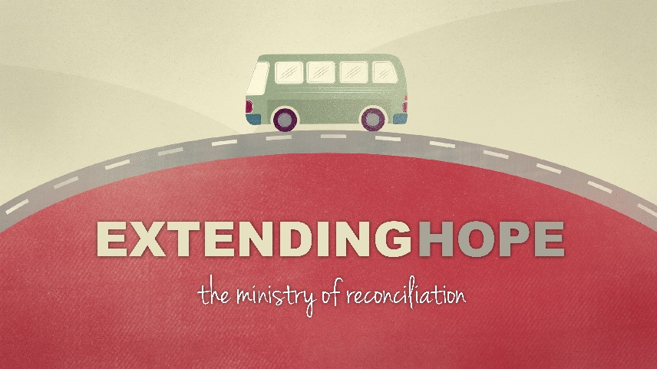

Introduction
Our core values are reflected in the things that we do-on purpose. The core value that makes people the most nervous is generosity. What if we changed the conversation from guilt or compulsion to kingdom investment and advancement?
Discussion Questions
- Why do you think the topic of money or giving or generosity can make people so nervous?

- If you had a church background growing up-what were you taught about money/giving? Why do you think that Jesus talked about money so much given that it appears he never really had any?

- Read Luke 12:13-21 Why was this a question that someone would shout out to Jesus? Vs 21 sometimes reads like a threat to us-what point is Jesus trying to make?

- Read Luke 12:22-34 There is a different audience for this teaching-what makes that significant? If starvation and poverty are still an issue in this world, why does Jesus say not to worry about it?

- Define generosity. What does it look like? Is generosity only about money?

- In the sermon, there were 2 mindsets mentioned from the book 7 Habits of Highly Effective People; Scarcity and Abundance- can you think of examples of those mindsets?

- How does seeking the kingdom first apply to how we handle our personal finances?
Shaping Your Mind - … And God’s grace was so powerfully at work in them all that there were no needy persons among them. For from time to time those who owned land or houses sold them, brought the money from the sales and put it at the apostles’ feet, and it was distributed to anyone who had need.
Acts4:34-35

