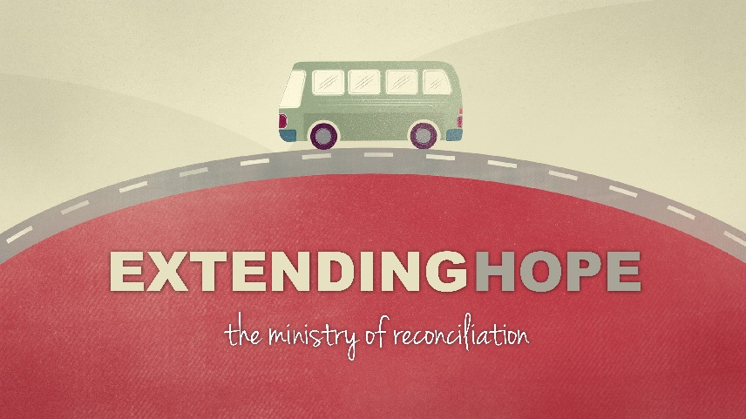

Introduction
If Northside is to be known as a place that Extends Hope-we have to be true to some core values. These values help us to live out our vision. Reminding ourselves of our mission and vision and values is a great thing to do so we can make sure we are in this together.
Discussion Questions
- Can you tell us about a time where you made yourself uncomfortable, but you are glad you did? What kinds of things take you out of your comfort zone?

- What do you believe the church (not specifically our church) is known for in Kansas City? Does Northside have a reputation in our community, if so what is it?

- Read 1 Corinthians 9:19-22 Do you think that Paul was ever uncomfortable “becoming all things to all people?” If it wasn’t natural to him or if he had to make himself do these things-why did he do it?

- Read Psalm 52:9 Why do you think David mentions the presence of faithful people? How is just being in each other’s presence a valuable thing?

- Read Mark 9:33-35 Why would the disciples argue about who is the greatest? Why is serving so important to faith development?

- Most of us don’t mind serving on some level, what we resist is being treated as a servant. How does that line up with what Jesus taught and modeled about servanthood? How can joy be found in service?

- In the last 2 sermons, there has been a lot of talk about Engagement. What’s the difference between attendance and engagement? Where are you engaging on our mission of making disciples through extending hope?
Shaping Your Mind - …Anyone who wants to be first must be the very last, and the servant of all.
Mark 9:35

