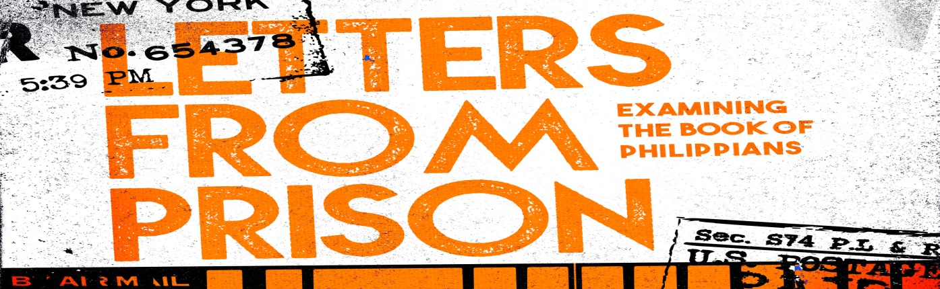
Introduction
A recurring theme in scripture is how God takes events that seem to be leading to defeat and turns them into a victory that no one really saw coming. As Paul writes from prison, he is aware that might be happening again.
Discussion Questions
- Describe an experience that you thought as you were going through it that it was the worst…but in hindsight it was really a good thing.

- Read Philippians 1:12-13 If you were a part of one of the churches that Paul started, what do you imagine you would be thinking/feeling when you hear that he is in prison in Rome? Do you think it would inspire you to share your faith, or be very cautious?

- Read Philippians 4:22- What is remarkable about this verse?

- Read Philippians 1:20-25 What is going on with Paul talking about not knowing which to choose? Explain the phrase – “to live is Christ, to die is gain.”

- Read Philippians 1:27-30 What does it look like to “conduct yourselves in a manner worthy of the gospel”?

- How can service bring joy in the midst of difficult circumstances? Have you ever witnessed or experienced this?

- Paul tells this church that they’ve been “granted” the opportunity to suffer. What might suffering for Christ look like in your context? How can suffering be a gift?

Shaping Your Mind – “For me, to live is Christ and to die is gain.” Philippians 1:21
Moving Forward – Whatever happens this week, conduct yourselves in a manner worthy of the gospel!

