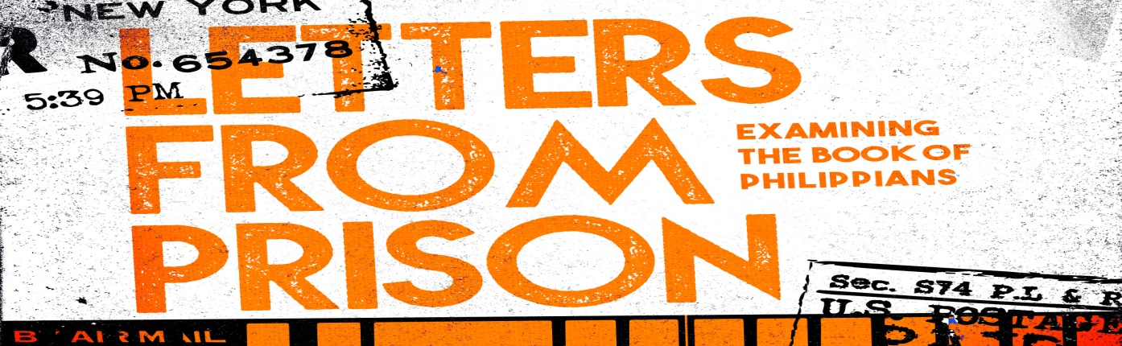
Introduction
There have been many incredible things written from a prison cell: letters about love and freedom; calls for justice and racial equality; examining the cost of being a disciple of Jesus. In the New Testament we have several letters written from prison. In this series we are going to examine how can those letters inspire and challenge us all these years later?
Discussion Questions
- Have you ever written or received a letter from prison? Most of us haven’t – if you were unjustly imprisoned, what would you write about?

- Read Acts 16:16-40 After Paul and Silas were arrested, they were beaten. That night they are singing to God? Explain that? How did their response to their own injustice impact others?

- Read Philippians 1:3-9 Paul says he thanks God every time he thinks of them. Why does he have such affection for this church?

- The word “joy” is used 13 times in this letter. In the sermon Jeremy said that joy and happiness are actually interchangeable throughout scripture, and that if we elevate joy to a deeper level than happiness, we actually push people away from the gospel. Respond to that idea-is there a difference between joy and happiness?

- Paul thanks God for their “partnership” with him in the Gospel. What does a partnership in the Gospel look like for individual Christians and for a church?

- Paul says he is confident that God will finish what he started in the Philippian church. What has God started in you that is not finished, but you are noticing changes?

- Is there a step you can take towards being a partner in the Gospel? How can the group help?

Shaping Your Mind – “And this is my prayer: that your love may abound more and more in knowledge and depth of insight, ¹⁰ so that you may be able to discern what is best and may be pure and blameless for the day of Christ,¹¹ filled with the fruit of righteousness that comes through Jesus Christ—to the glory and praise of God. Philippians 1:9-11 NIV
Moving Forward – Remember that God will finish what he has started in you-so let him!

