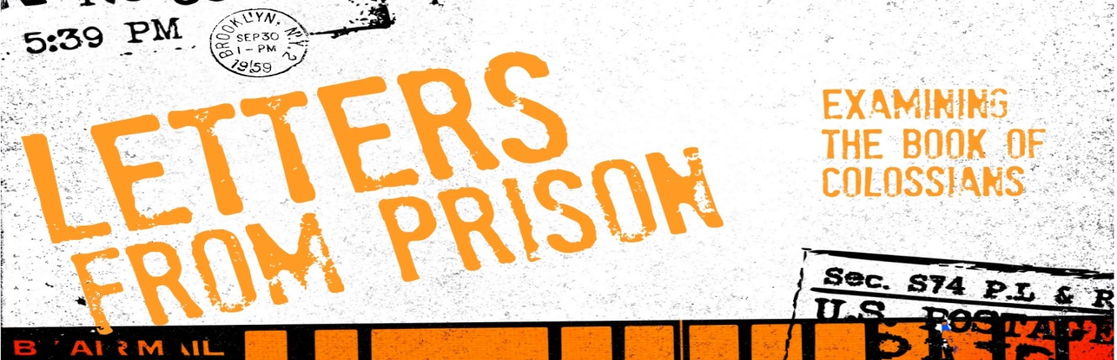
Introduction
The letter to the church in Colossae is a letter about the “main things.” Over the course of the letter Paul is going to lay out – Who Jesus is? What is the Gospel? How you can join in the Gospel, Why there is still a struggle within you? And How does this work in your closest relationships?
Discussion Questions
- If someone was to ask you what the most important part of Christianity is-or what’s the main thing…what would you say?

- Read Colossians 1:21-23 Based on these verses, what is the gospel?

- Read Colossians 2:8-15 According to this, how do you become “in Christ?” Why does Paul compare circumcision and baptism?

- Read Colossians 2:20-23 Why can there be a natural pull towards legalism in Christianity? What is the danger of legalism? If we have freedom in Christ, why do we teach or practice the idea of restraining that freedom at times?

- What kind of religious practice that we participate in can slide into legalism? In what ways could we be tempted to trust our religious practices (like baptism, communion, morality) instead of trusting Jesus for our righteousness before God?

- If we are trusting Jesus to make us right before God, why is baptism even necessary?

- What kinds of things are you doing or can you do to ensure that you are rooted in Christ and built up in him?

Shaping Your Mind – “I am the vine; you are the branches. If you remain in me and I in you, you will bear much fruit; apart from me you can do nothing. John 15:5
Moving Forward – May you trust Jesus and grow in Him!

