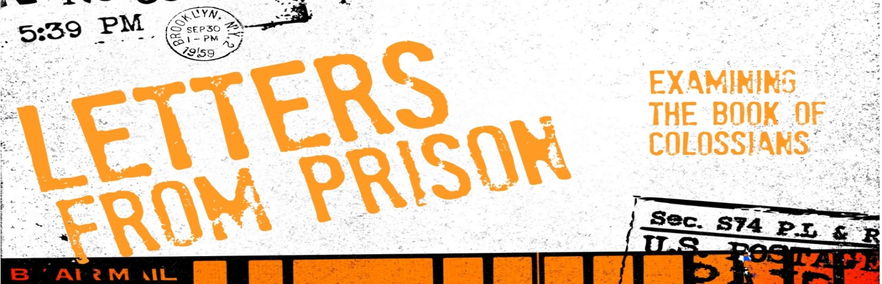
Introduction
There have been many incredible things written from a prison cell: letters about love and freedom; calls for justice and racial equality; examining the cost of being a disciple of Jesus. In the New Testament we have several letters written from prison. In this series we are going to examine the letter Paul wrote to a church he didn’t even start-the letter to the Colossians.
Discussion Questions
- What’s the most exciting thing you can remember ever receiving in the mail?

- Read Colossians 1:1-14 Why does Paul write to them? What do you think there response would be to the idea that Paul, who most had never meant and was in prison, was praying for them?

- What are the things that Paul is praying for this church? What does it mean to be filled with the knowledge of God’s will? What is God’s will for the Colossian church? Is it the same for our church today?

- Read Colossians 1:15-20 What is Paul saying when he says that Jesus was the first born over all creation? What does it mean when he says that nothing was created without him?

- Paul says that Jesus is the image of the invisible God. When you think of God, what do you think about? In the sermon, it was said that if you want to know what God is like-look at Jesus. How does Jesus affect your view of God?

- When we talk about Jesus being the guide or blue-print for how to be human-what does that look like? How can you tell if you are becoming more like Jesus?

- Is there something that looking at Jesus reveals that you need to begin to shape after him or let him deal with?

Shaping Your Mind – “For God was pleased to have all his fullness dwell in him, ²⁰ and through him to reconcile to himself all things, whether things on earth or things in heaven, by making peace through his blood, shed on the cross. Colossians 1:19-20
Moving Forward – May Jesus fullness dwell in you and his Father’s dwelt in him!

